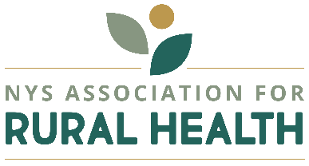
Nancy McGraw, Chair
2:15 p.m. Thursday, November 14, 2024

Finance Committee Meeting
Zoom Link:
https://nysarh-org.zoom.us/j/86931555148?pwd=wn5RngQbUAm4ZhKqYDEwAA8HsQEU2w.1

Meeting ID: 869 3155 5148 Passcode: 537683

One tap mobile
+16465588656,,86931555148# US (New York)

Agenda

- Call to Order Nancy
Agenda Modifications
Disclosure of Conflicts

- 2025 Projected Budget Review Nancy/Liz

  - Vote to move projected budget forward or change Nancy

- Committee Chair Contributions/Discussion TBD (Ali Coates and/or Chairs)

- Discussion and Projects, Deadlines Nancy
- General Expense Reimbursement Form (for approval)
- Grants Update
- Legislative Appropriation 2024-25: Update and Q/A Sara
- Other Announcements

- Adjournment
  - Next Meeting: Thursday, December 5, 1PM

