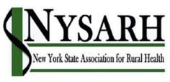
Membership Committee
September Meeting
September 14, 2021
Agenda

Join Zoom Meeting
https://us02web.zoom.us/j/83300176293
Meeting ID: 833 0017 6293
Passcode: NYSARH

- Quorum & welcome Mike Pease
  - Ella James, VISTA Member

- Approval of July 27 notes Mike Pease

- Digital on Demand All
  - Feedback from members who tried the training
- Rural Health Symposium Helen Evans
  - Promote registration with Prospective members
  - Share link widely on your communication channels
  - https://nysarh.org/2021-symposium/

- Student Advisory Committee update Mandy Qualls

- AmeriCorps Member Edad Mercier Sara Wall Bollinger
  - Third Tuesday 1PM conflicts with a class;
Can members change to second Tuesday at 9AM or Noon?
- Annual Report
https://nysarh.org/wp-content/uploads/2021/08/NYSARH-2020-Annual-Report.pdf
- Adjourn

Next Meeting: TBD based on member input

