NYS Legislative Appropriation
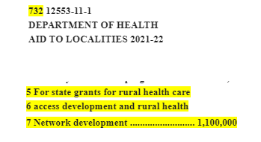

From: Nittinger, John P (HEALTH) <john.nittinger@health.ny.gov>
Sent: Friday, July 2, 2021 11:12 AM
To: Helen Evans <evansh@ardentnetwork.org>
Cc: abdella@a2rh.net
Subject: RE: Webex Meeting for NYSARH Legislative Appropriation contract

Hi Helen,

This webinar will focus on the 2021/22 contract. The 2019/20 contract is complete and there is no documentation required on our end.

John

