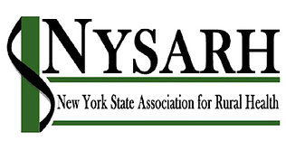
Policy Committee
Tuesday, July 27, 2021
10:00-11:00AM
Barry Brogan, Chair

AGENDA
Join Zoom Meeting
https://us02web.zoom.us/j/81309543569
Meeting ID: 813 0954 3569
Passcode: NYSARH

- Welcome and Roll-call Barry
  - Agenda Modifications

- Accept Minutes of 6.15.21 Barry

- Final Rural EMS Report Emily

- Policy Panel at Symposium All
- Senator May - accepted
- Senator Gallivan - declined
- Senator Stec -
- Assembly Member Woerner - accepted
- Assembly Member Byrnes - accepted

- Closing the Loop:
- Rural Health Council Ann A.
- Legislative Appropriation Ann A.
- Voter Voice Sara
https://www.ruralhealthweb.org/advocate/rural-health-advocacy-campaigns

- Federal ‘Infrastructure’
https://www.ruralhealthweb.org/advocate/nrha-legislative-tracker
Draft letter to Senators Gillibrand and Schumer

- Other Business All
- Adjourn Barry

