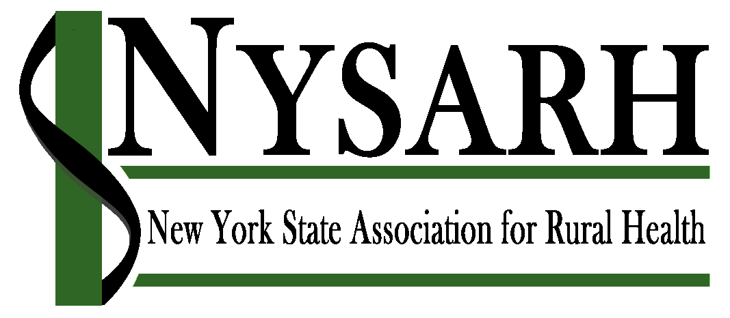

Board Member Job Description
The New York State Association for Rural Health (NYSARH) is a not-for-profit organization established in 2001 with the mission of improving the health and well-being of New York State’s rural people and communities. The organization is governed by a Board of Directors with no fewer than fifteen (15) and no more than twenty-one (21) voting members representing diverse geographies and sectors. Membership on the NYSARH’s Board of Directors provides a unique opportunity to support the mission and function of the organization while being part of a diverse network of people that share a passion for and commitment to improving the health of NY’s rural people and places.

Expectations of Board service
Serving on NYSARH’s Board of Directors requires real commitment. This is a working board, and every member is expected to do the following:
- Prepare for and attend bi-monthly board meetings (typically, by phone/video)
- Serve on at least one Committee of the Board or the Corporation, which includes participating in its meetings (typically, by phone/video) and contributing to committee work between meetings
- Participate in planning and promoting NYSARH events
- Contribute to capacity-building efforts, including developing new revenue from grants, contracts, services, sponsorships, etc.
- Support the annual membership drive, and year-round efforts to recruit new members and re-engage lapsed members
- Participate in NYSARH’s advocacy efforts at the state and federal levels
- Serve as an ambassador for the organization, seeking connections and linkages with individuals and other organizations that would advance the work of NYSARH
- Represent the organization, when expressly requested by the Board, at conferences and other events
- Abide by the bylaws, code of conduct and other polices that apply to the board
- Establish, review and monitor polices that guide core operational practices (eg. financial management, human resource management)
- Participate in the periodic review of NYSARH’s mission and objectives and the development of strategic plans
- Monitor the performance of the organization in relation to objectives and core values
- Keep informed about community issues relevant to the mission and objectives of NYSARH
- Participate in policy, management and election discussion and decisions
- Exercise voting rights
- Assist in the creation of standing, special and/or ad-hoc committees as needed
- Work as a team member and support board decisions
- Demonstrate board member responsibilities of care, loyalty, and obedience

Term of service
The term of service is three (3) years initiated by election by the Annual Meeting of the Association in September. Generally, Board members may not serve more than three consecutive terms.

Estimated Time commitment
- Participation in bi-monthly meetings of the Entire Board: 2 hrs/meeting (with prep)
- Service on at least one committee of the board or corporation, including meetings (~12 hrs/committee/yr) and work between meetings (~12 hrs/committee/yr)
- Other work on behalf of NYSARH, such as attending NYSARH events, participating in its advocacy initiatives, etc.: 12-18 hours/year

Duties and Authority
As per the Association’s corporate bylaws, the duties of Board Members are as follows:
- Employ, elect, or remove any officer, agent, or employee of the Association; prescribe such powers and duties for them as may be consistent with the laws of the State of New York, the Certificate of Incorporation, and the corporate Bylaws; fix their compensation, if any, and require of them, if it so wishes, security for their faithful performance
- Cause to be kept a complete record of all minutes and acts, and to present a full statement at the annual membership meeting showing in detail the condition and affairs of the Association
- Manage the affairs of the Association and report its activities to the membership at the annual meeting
- Act as trustee for all property, real and personal, of the Association
- Adopt the annual Association budget
- Approve and authorize all unusual or extraordinary expenditures of the Association’s funds
- Adopt such rules as are necessary to conduct its affairs
- Establish committees and define their duties, except as otherwise provided in these Bylaws
- Approve the appointment of official representatives and define their duties
- Act on business not otherwise provided for by the Certificate of Incorporation and Bylaws
- Fill vacancies consistent with the intent of the Bylaws

As per the Association’s corporate bylaws, there are limits to the authority of individual members of the Board. Specifically, individual board members have no authority to approve actions by NYSARH, speak on its behalf, or direct its staff, unless expressly given such authority by the Board.

