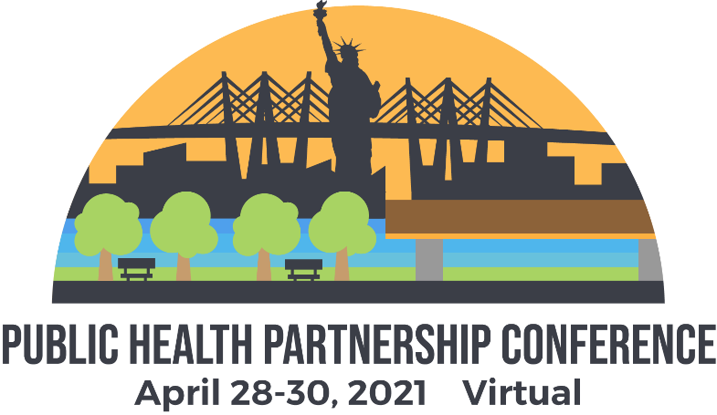

Conference Summary
The conference was a hybrid of the 2020 NYSPHA/NYSACHO conference that had to be cancelled and new content added in 2021. The Conference of Environmental Health Directors were minimally involved. NYSARH was added to the Partnership in December.
The decision to go 100% virtual was not made until January. The planning team selected the Whova conference ap and a few training sessions were scheduled.
NYSPHA has no full-time staff and relies heavily on graduate student interns to manage the conference. The intern assigned over the winter dropped the ball, but several new interns joined in March who stepped up to insure that the conference went smoothly.
The conference registration, finances and logistics were hosted by NYSPHA. Some adaptations were made to include NYSARH. NYSARH made a parallel portal for sponsors and exhibitors because the NYSPHA portal was not intuitive to use. This resulted in some duplication of effort, but likely secured more sponsors and exhibitors.
We plan to work together again for the 2022 conference. These issues will be resolved in advance of the registration going live next time.
Dashboard
208 Registrants
9 Sponsors
17 Exhibitors

Highlights of the Conference
Keynote Address by APHA President José Ramón Fernández-Peña, MD, MPA
Keynote Panel on Local Health Department Response to COVID-19
Emerging Issues Panel
The Poster Sessions were phenomenal - so much interesting research!
Engagement
762 Profile Views
560 Community Board messages
4 Meetups organized
44 Leads generated by Exhibitors
51% of Attendees set up a Personal Agenda
169 Attendees watched 26 sessions
1106 Private messages
11 Private group chats
1074 1:1 Attendee interactions

Evaluation
52 evaluations had been submitted as of 5/7
Feedback has been generally positive
The Planning Team has some concerns about Exhibitor experience. NYSARH made a supplemental survey just for Exhibitors. Results are not yet available.

Finances
The conference was definitely net positive for NYSARH. Final figures are not yet available, but we estimate that NYSARH will meet or exceed the budgeted revenue of $8,000 from Sponsors and Exhibitors.

Resource Guide
All registrants will receive a digital Resource Guide as a follow up to the conference. This booklet includes advertisements [$100-$200] not included in the above net income estimate, as well as articles and conference recaps.

If you attended the conference, please share your impressions at the Board Meeting.

