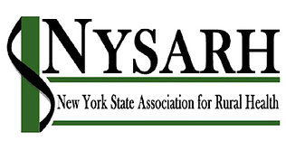
Policy Committee
Tuesday, April 20, 2021
10:00-11:00AM
Barry Brogan, Chair

Via Zoom
Apr 20, 2021 10:00 AM Eastern Time
Join Zoom Meeting
https://us02web.zoom.us/j/85814464621
Meeting ID: 858 1446 4621
Passcode: NYSARH

AGENDA

- Welcome and Roll-call Barry
  - Agenda Modifications

- Accept Minutes of 3.16.21 Barry

- Closing the Loop
  - Ann A. will check with Karen Madden
re: who has been nominated to the Rural Health Council.

- NYS Budget Wrap Up All

- Other Business All
- Adjourn Barry

Next meeting: May 18, 2021
10:00-11:00

