DRAFT
AmeriCorps Planning Grant April 2021
A. Executive Summary Please complete the executive summary per the instructions in the Notice.
B. Selection Criteria
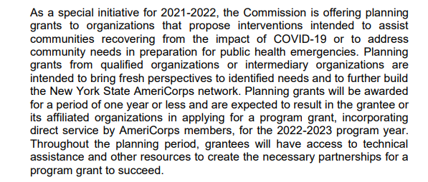
- Program Design (50 percent) In assessing Rationale and Approach/Program Design, reviewers will examine the degree to which the applicant demonstrates how AmeriCorps members, and the proposed intervention are particularly well-suited to addressing the identified community problem.
NYSARH will identify 6-10 Partner Organizations located in the targeted North Country and Mohawk Valley economic development regions to prepare them to effectively host an AmeriCorps member in 2023 and future years.
The population targeted for future services are adults 18-64 years old living in rural communities who have not completed a college education. The target population has an annual household income below the Area Median Income established by HUD.
The COVID-19 pandemic has brought to light evidence that people in rural communities, particularly young men, place high value on personal freedom and choice. They have a high tolerance for personal risk and relatively low participation in all forms of preventative healthcare and wellness promotion. Their perception of a need to protect others tends to be confined to immediate family and friends.
While these beliefs seem to indicate a narrow view of personal responsibility, these same people are the volunteer fire fighters, youth sports coaches and grange leaders of their communities. There is more to this story.
The Planning Grant time will be used to design interventions to effectively reach this rural population of adults 18-64 with public health, disease prevention and safety messages and approaches that take these core values into consideration.
NYSARH and the selected Partner organizations will use interviews, focus groups, website engagement, social media and surveys to better understand the values and interests of the target population. The team will use this information to design public health interventions that will be assigned to AmeriCorps members in future years.
The Planning Grant includes consultation with an established academic research university for quality assurance.
- Organizational Capability (25 percent) Reviewers will assess the extent to which the applicant demonstrates organizational background and staffing and structures, including compliance and accountability, to support the proposed program.

NYSARH is a volunteer-led organization founded in 2001. For many years, the agency budget was less than $100,000. In 2019 NYSARH received a contract with NYSDOH to administer a $1.1 million past-through appropriation that, due to the pandemic, was not completed until April 2021. As a result of this larger budget, NYSARH has implemented a higher level of compliance accountability at the Board level and has Audited its financial statements.

NYSARH is staffed via contract with Health Workforce NY. If NYSARH is awarded a contract with AmeriCorps, the Project Coordinator will be hired by Health Workforce NY.

- Cost Effectiveness and Budget Adequacy (25 percent) In assessing Cost Effectiveness and Budget Adequacy, reviewers will examine the degree to which the budget is cost effective and appropriate for the program being proposed. Enter N/A in the narrative as the assessment will be of the budget.
PRELIMINARY BUDGET
Program Coordinator 40,000
Fringe 10,000
University Consultation 10,000
OTPS - all sorts of things 5,000
NYSARH Administration 10,000
C. Evaluation Summary or Plan If you are competing for the first time, please provide your data collection plan in the Evaluation Summary or Plan field. Please follow the instructions in the Notice.
The goal of this Planning Grant is to develop a Theory of Change specific to the Rural Upstate New York population. https://www.theoryofchange.org/what-is-theory-of-change/ NYSARH believes that public health messaging developed for the State overall will not be effective, as it tends to target Urban populations. We believe NYSARH can provide a unique RURAL addition to New York State’s body of knowledge.

