AmeriCorps Planning Grant
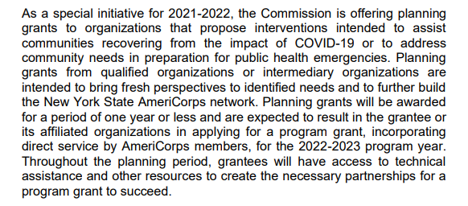
Application due 4/28/21!
The first level of review is carried out by the Administrative Team of NYSARH utilizing the Funding Review Checklist that evaluates if the funding does the following:
√1. Aligns with the Articles of Incorporation
√2. Aligns with Mission/Vision of the Corporation
√3. Aligns with State/Federal efforts
√4. Aligns with NYSARH Advocacy efforts
√5. Aligns with NYSARH priorities
√6. NYSARH meets the minimum eligibility requirements
√7. NYSARH meets the preferred edibility requirements
√8. NYSARH falls within the catchment area
√9. NYSARH has capacity to successfully carry out all deliverables
√10. The funding includes dollars for administration
√11. The funding includes dollars for staff (how many, new or existing)
One Project Coordinator
√12. New York State Association for Rural Health can meet the requested deliverables
√13. The efforts can be sustained
There is an expectation that NYSARH compete in the next round
14. If funding requires collaboration, and if so with whom
Interested RHNs in targeted region = North Country & Mohawk Valley
√15. NYSARH can meet the reporting requirements
Once completed, the form with any recommendation is forwarded to the Executive Committee via email for review. The Executive Committee will have 72 hours to respond with their thoughts and/or recommendations. The Executive Committee will approve or reject pursuing the opportunity based on the form.

