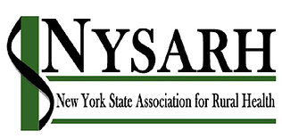
Policy Committee
Tuesday, March 16, 2021
10:00-11:00AM
Barry Brogan, Chair

Via Zoom
https://us02web.zoom.us/j/85814464621
Meeting ID: 858 1446 4621
Passcode: NYSARH
646.558.8656 US (New York)

AGENDA

- Welcome and Roll-call Barry
  - Agenda Modifications

- Accept Minutes of 2.16.21 Barry

- Closing the loop: Iroquois Sara

- NYS Advocacy Next Steps Barry

- Definition of Rural Ann

- Rural Health Clinic issue Sara

- Other Business All
- Adjourn Barry

Next meeting: April 20, 2021
10:00-11:00
Thereafter Third Tuesdays at 10AM

