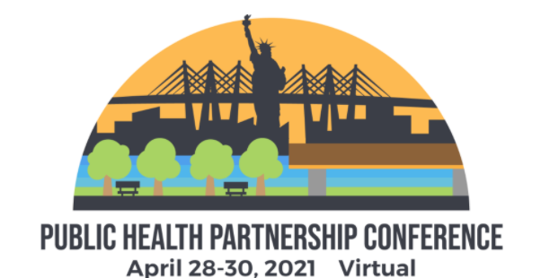

In keeping with our Strategic Plan focus on Collaboration, NYSARH is partnering with NYSACHO, CEHD and NYSPHA to produce this conference. NYSARH does not plan to offer a Rural Health Conference in 2021. This is a big change for us!

Overview
Wednesday morning: Digital Check-in
Wednesday afternoon: Welcome, Session on suicide/opioid, Whova logistics, Exhibits, Networking cooking show & dinner
Thursday morning: Wellness, Breakouts
Thursday afternoon: Posters, Exhibits, Breakouts, National Keynote, Award Ceremony, Networking [magic!]
Friday morning: Wellness, Breakouts
Friday afternoon: Posters, Exhibits, Breakouts, National Keynote, Closing Ceremony
Register Here:
https://www.nyspha.org/event-3631863 NYSARH Code: GLKJJ8A9

Agenda Here:
https://www.nyspha.org/page-1861329

Sponsor Here:
https://nysarh.org/conference-2021/sponsor/

Please Register!

The Conference financial model is based on 100 registrants each from NYSPHA, NYSACHO and NYSARH and 50 from CEHD for a total of 350 attendees. We may be a little short this year because expenses for Virtual are lower, but next year the plan is to be in-person and hitting these numbers will be critical for financial success. The Conference is NYSARH’s largest fundraiser.

