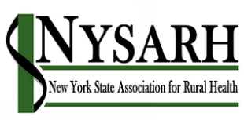

Governance Committee
Agenda
March 15, 2020

Join Zoom Meeting
https://us02web.zoom.us/j/87652615473
Meeting ID: 876 5261 5473
Passcode: NYSARH
One tap mobile
+16465588656,,87652615473# US (New York)

- Welcome & Roll Call Claire
Agenda Modifications
Disclosure of Conflicts

- Review/approval of notes from January 11 All

- Status of legal consultation Claire

- Discuss any changes to the bylaws that should be considered All

- Changes to the Disclosure Form Claire

- Adjournment All

