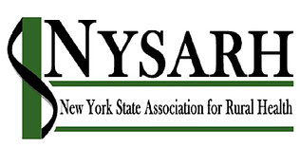
Policy Committee
Tuesday, February 16, 2021
10:00-11:00AM
Barry Brogan, Chair

Via Zoom
https://us02web.zoom.us/j/85814464621
Meeting ID: 858 1446 4621
Passcode: NYSARH
646.558.8656 US (New York)

AGENDA

- Welcome and Roll-call Barry
  - Agenda Modifications

- Accept Minutes of 1.13.21 Barry

- NRHA Policy Institute Ali & Ann
  - Report on Virtual Conference
  - Congressional virtual visits are planned the week of 2/22
Please sign up for visits
https://drive.google.com/file/d/1O_6CYmZ-MetbT_JIhUNI1Wf9JCNc1Myy/view?usp=sharing

- NYS Advocacy Next Steps Barry
- What did we learn from Legislators?
- Budget Testimony
- Letter of Support for EMS Task Force

- Other Business All
- Adjourn Barry

Next meeting: March 16, 2021
10:00-11:00
Thereafter Third Tuesdays at 10AM

