NYSARH Article for the Legislative Commission on Rural Resources Spring 2021 Newsletter
A review of previous editions indicates that we need to keep this article to one page and that a picture or two will be welcome. The previous newsletter addressed the onset of COVID-19.
I assume this edition hopes to feature successful management and optimism.
The unsung heroes of the COVID-19 response in rural communities have been County Public Health Departments. These dedicated professionals who had previously visited families with premature newborns, tested well water for contaminants, provided health education, and maintained numerous health data surveillance metrics were suddenly at ground zero for a global pandemic. They rose to the address the need. County Public Health Departments have set up multiple testing sites and assigned contact tracers when residents test positive.
“Rural families struggled during 2020. Traditional supports from schools, friends and coworkers were more challenging to access. The unemployment rate is high and working from home is difficult in areas with poor broadband coverage and children at home. Social care agencies have been hampered by budget cuts at a time when their services are needed most.” Helen Evans, NYSARH Board President
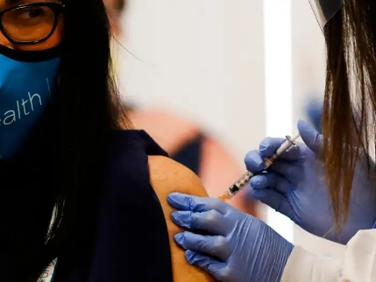
Rural hospitals, health centers and behavioral health providers have risen to the challenge. After massive restructuring in the spring, they are now providing high quality, personalized care with both safe in-person and remote telehealth options. Visit volume has leveled off at about 75% of 2019 levels, indicating that some people are still not comfortable accessing healthcare.
One in five rural residents receive their healthcare from a federally qualified health center. The federal government provided funding to ensure that these centers had PPE, site renovations and COVID-19 testing kits. Now these essential providers have begun administering vaccinations.
Readers may be interested in resources provided by the Rural Surge Readiness Team: https://www.ruralhealthinfo.org/healthcare-surge-readiness
Rural communities include several institutional settings such as nursing homes and prisons that were hard hit by the virus. The needs of their employees, going in and out of these institutions, has been a priority for testing and vaccinations. Our hearts go out to friends and family members who have not been able to visit in-person for many months.
We are hopeful that the immunization plan will greatly reduce the spread of the virus.

