Appropriation Advocacy Update as of COB 12/18/20

Letters sent 12/10/20
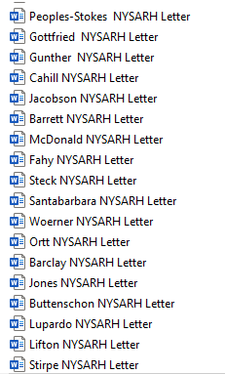
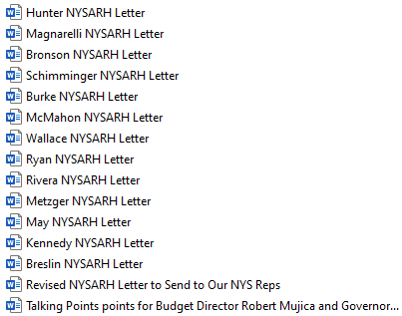

Responses

Phone call from Didi Barrett staffer [Ethan Pine]
Question re: 20% hold back from John McDonanld
Bill Magnarelli [Daniel Patrick] sent a letter to Mujica
Al Stirpe sent a letter to Cuomo
Robert Ortt [Erica Wenner] ‘reached out to DOH to inquire on this’

