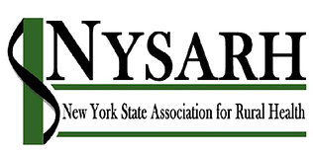
Policy Committee
Wednesday, September 23, 2020
9:00-10:00AM
Barry Brogan, Chair

Via Zoom
https://us02web.zoom.us/j/9593230035
Meeting ID: 959 323 0035
Passcode: NYSARH
One tap mobile
+16465588656,,9593230035# US (New York)

AGENDA

- Welcome and Roll-call Barry
  - Agenda Modifications

- Accept Minutes of 7.16.20 & 8.11.20 Barry

- 2020-21 Talking Points Barry

- Adirondack Health Institute Policy Agenda Sara
  - Invitation to collaborate

- Updates Sara
  - Senate Minority Leader Robert Ortt meeting 9/24 3pm
  - Assembly Minority Leader Will Barclay meeting 9/23 12:30pm
  - Letter to federal delegation sent 8/21
  - Vaccine distribution letter with NYSACHO & NYSPHA
    - Still in process
  - S.3599 / H.R.6788 - Healthcare Workforce Resilience Act (HWRA)
  - 340B

- Other Business All
- Adjourn Barry

Next meeting: October 28, 2020

