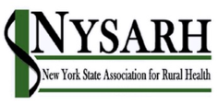

Governance Committee Meeting of August 3, 2020

Call to Order and Roll Call
Board Members present at roll call: Claire Parde, Ann Battaglia, Helen Evans,
Gertrude O’Sullivan
Staff Member: Sara Wall Bollinger

Discussion Topics: Reviewing the draft Ballot Summary

Discussion Summary
We are still missing a few details from candidates; Claire will follow up with the candidates to secure this prior to the next meeting.

Adjournment
The meeting adjourned at 11:22

Next Meeting
August 17th at 11 AM

