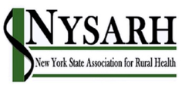

Governance Committee Meeting of August 17, 2020

Call to Order and Roll Call
Board Members Present at Roll Call: Claire Parde, Ann Battaglia, Gertrude O’Sullivan
Excused: Board Member Helen Evans
Staff Member: Sara Wall Bollinger

Discussion Topics: finalizing the Ballot Summary; scheduling the election

Discussion Summary:
Gertrude suggested that the ballot include the candidates’ title, company and region. A link to the survey will be in the email and in the Ballot Summary document.

The Annual Meeting will be September 21st at 11 a.m.

Action Items:
- Sara will create the Ballot in Survey Monkey
- Sara will send the draft Survey Monkey to Claire for approval and distribute it to all Members on August 17th with a due date of September 17th

Adjournment
Meeting adjourned at 11:30 a.m.

Next Meeting
September 28th at 11 a.m.

