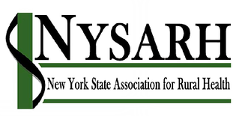
NYS Association for Rural Health
1 Main Street Suite 202
Canton, NY 13617
315-378-7701
info@NYSARH.org
www.NYSARH.org

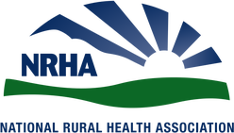
2020-21 Rural Health Advocacy

2020-21 NYSARH Talking Points
Fully fund wellness promotion and disease & accident prevention programs
- Address the primary causes of mortality and morbidity in NY
- Support the Prevention Agenda
- Fund Public Health initiatives

Rethink current approaches to non-emergency medical transportation
- Preserve rural public transportation
- Improve customer service
- Save money

Explore new paradigms for rural EMS
- Support volunteer engagement
- Increase training flexibility
- Approve and establish payor guidelines for Mobile Medicine
- Increase Medicaid reimbursement

Additional Priorities
- Legalization of Marijuana
- Rural Broadband
- Immunization
- Rear Seat Belts
- Health Insurance Coverage

Restore Funding for Rural Health programs: Rural Health Network & Rural Health Access Development
- Release supplemental appropriation

Build capacity to provide more comprehensive, accessible, timely, affordable and effective behavioral healthcare.
- Standardize licensure/certification
- Provide fair payment to Peers
- Provide SUD services in local jails
- Expand Supported Housing
- Coordinate and make permanent flexible regulations for Telehealth

Workforce Recruitment & Retention
- Area Health Education Centers
- Doctors Across New York
- Diversity in Medicine
- Rural Residency Programs

Prompt Contracting & Payment
- Respect the organizations that contract with NYS

NYSARH Members are…

Rural Health Networks
Area Health Education Centers
Medical Providers
Federally Qualified Health Centers
Behavioral Health Agencies
County Public Health Departments
Hospitals & Urgent Care Centers
Schools of Higher Education
Health Foundations
Long Term Care Providers
Disease Prevention Organizations
Veteran Organizations
Community Action Agencies
Emergency Services

NYSARH Members …
Administer unique programs, tailored to rural communities
Deliver prevention and education services
Develop the health professionals of the future
Engage with DSRIP Performing Provider Systems
Implement Population Health Improvement Programs
Navigate healthcare and health insurance
Offer continuing education and internships
Partner with other organizations to leverage resources and maximize impact
Prepare for value-based payment
Provide or coordinate transportation
Reduce unnecessary hospital and emergency department visits
Solve community challenges at the community level

NYSARH …
Advocates for the health and well-being of Rural New Yorkers
Facilitates networking and collaboration across Upstate New York
Participates in the Rural Health Policy Institute in Washington, DC
Produces the premier Rural Health Conference in New York State
Publishes a Quarterly Newsletter
Works in conjunction with the NYS Office of Rural Health
Represents New York with the National Rural Health Association

www.NYSARH.org

