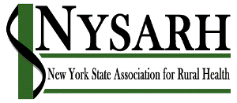

2020-2021 NYSARH Board Governance Calendar

Timing Task Designee
September Host the Association’s Annual Membership Meeting Entire Board
Appoint Committee Chairs President
Confirm Committee Composition Staff
Prepare and disseminate Board and Committee meeting calendar Staff
Provide Annual Conflict of Interest Training Governance

October Collect Disclosure of Financial Interest Forms Governance
Update Board Composition and Recruitment Matrix Governance
Prepare application for NRHA Technical Assistance Program Funds Staff & Exec

November Evaluate Disclosures of Financial Interest Governance
Participate in National Rural Health Day Advocacy Initiative by making in-district legislative contacts All members
Develop Annual Budget Finance
Approve application for NRHA Technical Assistance Program funds Entire Board

December Develop annual legislative agenda Policy

January Initiate annual financial review Entire Board

Jan-April Conduct advocacy around state budget Policy

February Participate in NRHA Policy Institute, Washington, DC Delegation

April Receive report on financial review Entire Board
May-July Consider current composition of the Board Governance Develop slate of candidates for Board membership and Offices Governance

July Conduct mid-year evaluation of vendor for Management Services Executive

August Initiate annual election of board members and officers Governance

