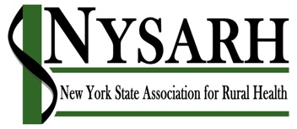
Board of Directors Meeting

July 23, 2019

11:00 AM – 12:00 PM
1-857-232-0476
Participant Code: 610224

AGENDA

I Roll Call & Quorum Karin

II Approval of Minutes (06.11.2019) Richard

III Agenda Modifications Richard

IV NRHA
- Report on NRHA Conference Derrik
- All of Us opportunity Sara

V Committee Reports
  - Policy Barry
  - Governance Claire
    - Board Nominees
    - Officer Nominees
  - Finance Rich
- IRS 990 & CHAR 500 wrap up
- 1st & 2nd Quarter financial Reports
E. Membership Jack
- Member Survey
  - Conference David/Charlotte
    - Registrations
    - Sponsorships
    - Award winners

VIII Administrative Report Sara
- Wrap up with Seven Valleys & Interim Contract
- Kick-off new Administrative arrangement with NAHEC
- Community Stars nomination opportunity (due 8/9)
- https://www.strongnonprofitsny.org/join-the-coalition

IX Other Business Richard

X Adjourn Richard

Attachments:
- BOD Meeting Minutes 06.11.2019 ( for approval)
- Draft Member Survey (for approval)
- Press release (for approval)
- Community Stars Nomination Form (for discussion)
- All of Us Opportunity (for discussion)

