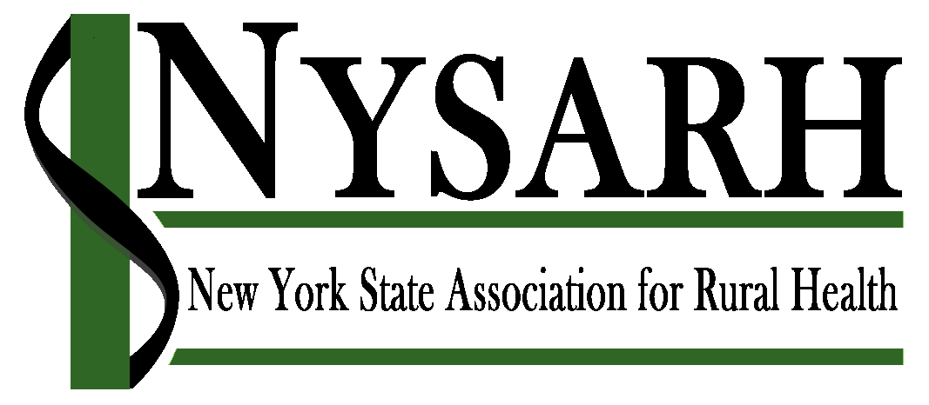

2019 New Board Member Application

NYSARH Members interested in being considered for service on the Board of Directors are invited to submit this signed and completed application by July 12, 2019 by email to info@nysarh.org or by fax to (315) 379-7707. Any questions may be directed to the Chair of the Governance Committee, Claire Parde, by email to cparde@columbiahealthnet.org or by phone at (518) 822-8820.

Part I. Contact Information

Name: ________Paul Pettit __________________________________________________________
Home Address: ___2636 Oak Orchard Road, Albion, NY 14411___________________________
Home Phone: ____________________________Cell Phone:______585-690-5317_____________
Personal e-mail address:______pajapettit@gmail.com_____________________________________________________
Employer:_____Genesee & Orleans County Health Departments_______________________________
Work Address:____14016 Route 31 West, Albion, NY 14411__________________________
Work Phone: _______585-589-3250___________________________________________________
Work e-mail address:_____paul.pettit@orleanscountyny.gov_________________________________
Occupation/Position:_________Director of Public Health____________________________________

Part II. Regional Representation
Please select the geography with which you work/identify:
- Lower Hudson Valley (Dutchess, Orange, Putnam, Rockland, Sullivan, Ulster and Westchester)
- Capital District/Northern Catskills (Albany, Columbia, Greene, Rennselaer, Saratoga, Schenectady, Warren and Washington)
- Adirondack (Clinton, Essex, Franklin, St. Lawrence, Jefferson, Lewis)
- Central NY (Cayuga, Cortland, Fulton, Hamilton, Herkimer, Madison, Montgomery, Oneida, Onondaga, Oswego, Schoharie )
- Southern Tier (Broome, Chemung, Chenango, Delaware, Madison, Otsego, Schuyler, Steuben, Tioga and Tompkins)
- Finger Lakes (Orleans, Genessee, Wyoming, Monroe, Livingston, Wayne, Ontario, Yates, Seneca)
- Western Region (Niagara, Erie, Chautauqua, Cattaraugus, Allegany)
- Elsewhere (please specify):__________________________________________________

Part III. Sector Representation
Please check the following that describes the sector you represent (check all that apply):

- Healthcare Providers/Practitioners
- Acute Care/Hospitals/Health Systems
- Community Health Centers/FQHCs
- Dental/Oral Care
- Aging/Long Term Care
- Home Care
- Emergency Medical Services
- Behavioral Health
- Pharmacy
- Military (active duty and veterans)
- Infants & Children
- LGBQT
- Human Service Agencies
- Supportive Service Agencies
- Public Health Organizations
- Health Planning Organizations
- Health Plans/Managed Care
- Healthcare Workforce
- Rural Economic Development
- Rural Health Networks
- Transportation
- Agriculture (industry and labor)
- Education/Academia
- Consumers
- Funders/Foundations
- Immigrant Populations
- Clergy
- Business & Industry
- Elected Officials
- Other rural stakeholder group (please specify): _______________________
_______________________________

Part IV. Eligibility
Please circle if the following statement is true or false

True False I am either an individual member or a representative for an organizational member of the Association.

Part V. Skills/Competencies/Areas of Expertise
Please check off any area in which you have background or expertise:

- Administration/Management
- Accounting/Fiscal oversight
- Legal
- Human resources/personnel management
- Marketing/Communications/PR
- Business development
- Early-stage organizations/startups
- Nonprofit Governance
- Strategic planning
- Membership recruitment/management
- Nonprofit program design/evaluation
- Fundraising/access to resources
- Education/training
- Leadership development
- Healthcare industry knowledge
- Clinical practice knowledge
- Policy/Advocacy/Government Relations
- Subject matter expertise (please specify):
- Telehealth
- Group Process
- Other (please specify): ___________________________________
Part VI. Other qualities
Please check off any additional qualities that you would bring to your board service:

- Connections to policy makers
- Connections to a national field/industry network
Please specify:__________________________________________
- Connections to particular communities and/or populations
Please specify:___________________________________________
- Connections to funders
- Passion for the mission
- Availability/capacity to work/follow-through
- Meeting facilitation
- Team/consensus building
- Vision/big picture/strategic thinking
- Communication skills
- Leadership
- Contributes to board diversity
- Other (please specify): _________________________________________________________

Please list the Boards on which you currently serve and any positions you hold (e.g. Committee Chair, Officer, etc.):____NYSACHO – Executive Committee - Immediate Past President, R-AHEC, Lake Plains Community Care Network, HEALTHeLINK, Western New York Public Health Alliance, Albion Running Club__________________________________

Please list any additional Boards on which you have served in the past five years and any positions held (Committee Chair, Officer, etc.):_______________________________________
____Same__________________________________________________________________________________________________________________________________________________________________________________________________

Please list any Volunteer Activities with which you are involved:_________________________
____Medical Reserve Corps, Faith based organizations, School functions__________________

Part VII: References
Please list three personal or professional references:

Name of Reference:___Charlotte Crawford____________________________
Title:__________Executive Director ________________________________________
Affiliation: _____Lake Plains Community Care Network___________________________
Phone Number:_______585-345-6610___________________________________________
Email Address:________ccrawford@lakeplains.org____________________________

Name of Reference:______Dan Stapleton___________________________________
Title:_________Public Health Director______________________________
Affiliation: ________Niagara County Health Department______________________________
Phone Number:______585-439-7458__________________________________
Email Address:______dan.stapleton@niagaracounty.com____________________________

Name of Reference:____Brenden Bedard________________________________
Title:______Director of Community Health Services___________________________
Affiliation: ____________Genesee/Orleans County Health Departments________________
Phone Number:___________585-589-2778____________________________________
Email Address:_________brenden.bedard@orleanscountyny.gov_____________________

Part VIII: Attestation

If elected to the NYSARH Board of Directors, I, ____Paul Pettit__, affirm that I am able to fulfill the duties and responsibilities of a NYSARH Board member, which include, but are not limited to, the following:
- Maintaining regular attendance at board and committee meetings [usually via telephone]
- Serving as a member of at least one committee of the board or corporation
- Assisting with and participating in the Annual NYSARH Conference
- Participating in the approval of the annual budget and the allocation of any available grant funding
- Maintaining general support of the Association and its purposes
- Participating in policy, management and election discussion and decisions
- Exercising my voting rights
- Assisting in the creation of standing, special and/or ad-hoc committees as needed
- Demonstrating board member responsibilities of care, loyalty, and obedience
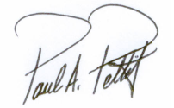 July 12, 2019
Candidate’s Signature Date

