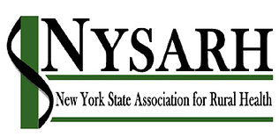
NYSARH Governance Committee Meeting
June 17, 2019

Board members present: Claire Parde (Chair), Richard Merchant, Ann Battaglia, Derrik Chrisler, and Carrie Roseamelia

Call to Order: The meeting was called to order by Claire Parde at 11:00 am

Discussion Summary:

Slate of Officers
Claire reported that the following Board Members have agreed to be nominated to office, as follows:
- Helen Evans, President
- Jack Salo, Vice President
- David Riddell, Treasurer
- Jenny Leszyk, Secretary
This slate of candidates for office will be reported to the Entire Board at its next meeting.

Review of New Board Member Application
The Committee reviewed the New Board Member Application and made several changes to reflect our new two-step process for selecting candidates for nomination to the Association Membership.

Review of Member Communication about nominations and election
The Committee reviewed a draft communication to Association Membership about the nomination and election process. The members agreed that the communication, Board Member Job Description, and 2019 New Board Member Application could all be disseminated to Membership at the earliest opportunity. Claire will follow up.

Update on Board Mentor Program
The Committee discussed the challenges of trying to meet in-person with new board member mentees; no pair has successfully accomplished this. The group agreed this is a not a reasonable expectation and will focus on telephonic communication instead.

Adjournment: The meeting adjourned at 11:41 a.m.

Next Meeting Date and Time: Monday, July 15th at 11:00 a.m.

