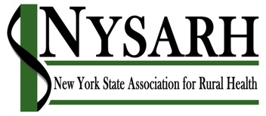
Board of Directors Meeting

June 11, 2019

11:00 AM – 12:00 PM
1-857-232-0476
Participant Code: 610224

PRELIMINARY AGENDA

I Roll Call & Quorum Kristin

II Approval of Minutes (03.26.2019) Richard M

III Agenda Modifications Richard M

IV Report on NRHA Conference Carrie

V Committee Reports
  - Policy Barry
    - Assembly Rural Health Hearing 5.31.19
  - Governance Claire
    - Call for Nominations
  - Finance Richard K
a. IRS 990 & CHAR 500
b. Wrap up with Freed Maxick
E. Membership Jack
- 2018 Annual Report
  - Conference David/Charlotte

VIII Administrative Report Sara

IX Executive Session David
- Administrative Services Vendor

X Adjourn Richard

Attachments:
- BOD Meeting Minutes 03.26.2019 (Presented for Approval)
- Testimony to NYS Assembly Health Committee (for information)
- 2017 & 2018 IRS 990 (for Information)
- Annual Report (Presented for Approval)
- Recommendation for Administrative Vendor (Presented for Approval)

