New York State Association for Rural Health Finance Committee Meeting
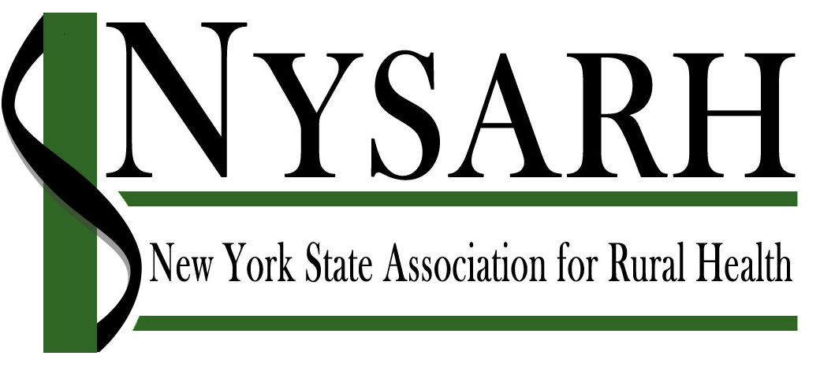
June 10, 2019
Via Tele-Conference

P = Present E = Excused
Richard Kazel, Treasurer | P | Helen Evans | P
Michael Pease | P | Richard Merchant | P
Sara Wall Bollinger | P | Katie Rafferty | P
Karin Blackburn | P | Nancy McGraw | E
 |  | Mary Zelazny | E

Topic | Discussion | Conclusions | Action
Call to Order  Richard Kazel, Finance Committee Chair | Meeting convened at 2:30PM
Agenda Modifications | None.
QuickBooks 2019 Update  Katie Rafferty, Accounting Manger | Katie worked with auditors at Pinto, Mucenski, VanHouse and Hooper to ensure that NYSARH is moving forward appropriately with the 2019 QuickBooks process. Staff at PMVH helped NAHEC update QuickBooks 2019 Desktop and uploaded backup information from Seven Valleys. All NYSARH back-up information is now stored and downloaded appropriately.
2017 990 & CHAR 500 Draft & Freed Maxick Update  Richard Kazel, Finance Committee Chair | NYSARH’s plan of action regarding IRS reporting was to have Freed Maxick submit the 2017 and 2018 990 & CHAR 500. Freed Maxick filed for an extension, which is approaching on 6/15.  Sara suggested that an adjustment was regarding Kathy Carpenter being listed as a NYSARH employee in the 2017 990. Richard Kazel contacted Katie, via email, regarding this information. |  | Katie Rafferty will follow-up with Freed Maxick to request this adjustment and request more information about the 2018 CHAR 500 & 990 extension.
2017 – 2018 Financial Binders  Katie Rafferty, Accounting Manager | Katie has now organized all historical paper documents that were received from Seven Valleys into three-ring binders. NAHEC received boxes of materials that were unsorted and not cataloged. The information is now sorted out in appropriately for easy access.
2019 Financial Reporting Update  Katie Rafferty, Accounting Manager | Katie is completing 2017 and 2018 QuickBooks work presently. 2019 QuickBooks work will be ready for submission to the committees and board by the beginning of July. Sara informed Katie that the Board is meeting on July 23rd and requested reporting for July 16th. |  | Katie will send 2018 990, and Quarter 1 and 2 Financial Reporting for 2019 to Richard Kazel and Sara Bollinger as soon these documents are available, and then to the full Board.
PayPal Processing Update  Katie Rafferty, Accounting Manager | Katie confirmed that PayPal doesn’t have high usage at this time. Katie states that she is in close contact with HWNY for PayPal processing. Katie receives PayPal payment updates daily via email, and works with HWNY to get this information into the appropriate systems and portals.
Current NYSARH Vendors Bills Katie Rafferty, Accounting Manager | Payments for Sara Bollinger, Freed Maxick, HWNY, and a reimbursement Derrick Chrisler are in process and will be signed on Wednesday by Richard Merchant. Richard Kazel confirmed that it would be appropriate, given travel status, that Richard Merchant, NYSARH President, signs checks for the time being. | Richard Merchant commented that as things transition, there will be some potentially new vendors starting July 1, everything will be ready to be handed off to the new financial manager for NYSARH, including 2017, 2018, and updated 2019 financial reporting.  Richard Kazel confirmed that smooth transition is what the Board is wanting NAHEC to ensure. | Karin and Katie will make sure that Richard will sign these checks on Wednesday, June 12th.  Katie will have files and financials complete for a smooth transition.
Adjourn  Richard Kazel, Finance Committee Chair | Motion to adjourn at 2:48pm.  (M. Pease/R. Merchant)

Respectfully submitted by Karin Blackburn, June 10, 2019.

