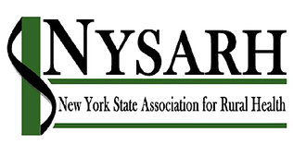
Policy Committee
Tuesday, June 25, 2019
9:00-10:00 AM EST

Barry Brogan, Chair

Via conference call
1-857-232-0476
610-224

AGENDA

- Welcome and Roll-call Sara

- Accept Minutes of 5/23 & 5/28 Barry

- Questions for member survey All

- Other Business All
- Adjourn Barry

Attachments:
- Sign on letters Meeks/Delgato
- Draft survey monkey questions

