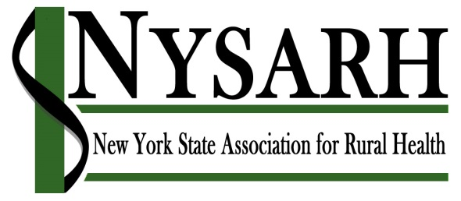

Board of Directors Meeting
January 22, 2019
11:00 am via Conference Call

Board Members: P= Present, E = Excused
Others Present: Jackie Leaf, Sara Wall Bollinger, Kristin Avery

Tess Barker | E | Richard Kazel | P | Michael Pease | P
Ann Battaglia | P | Jennifer Leszyk |  | David Riddell | P
Barry Brogan | P | Karen Madden | P | Carrie Roseamelia | P
Derrik Chrisler | E | Nancy McGraw | E | Jack Salo | E
Charlotte Crawford | P | Richard Merchant | P | Robert Wingate | P
Helen Evans | P | Gertrude O’Sullivan | E | Mary Zelazny | P
Sylvia Getman | P | Claire Parde | P
- Welcome: Jackie took roll call. Quorum being established, Richard M. called the meeting to order at 11:04 AM.

- Minutes: Mike moved to approve the minutes of 11/27/19. Carrie seconded. Motion passed.

- Committee Reports

  - Policy Committee, Barry Brogan
Committee met on 1/22/19. Looks like in NYS budget, there is level funding for RHN and AHEC. Still living with cut from 2 years ago. Strategy will be to reinforce governor’s proposal, but articulate ramifications of cut. Some rural health programs did get pooled. PHIP was cut completely; will be adding to our advocacy priorities. Other priorities: non-EMT transportation; workforce issues; behavioral health providers.

Policy developments: pull together a briefing to help educate us on: EMS, non-medical transport, state’s opioid strategy (Governor’s budget looks aggressive, but actually takes money from other programs to fund opioid programs.) A webinar will be held on 2/12/19 regarding one of the 3 topics.

NRHA Policy Institute in Washington, DC is 2/4/19 to 2/7/19.

Advocacy Day in Albany is 1/28/19. Encouraging members to attend. 9-10:30 AM is a briefing, then appointments with legislators throughout the afternoon.

  - Membership Committee, Jack Salo
Sara spoke on behalf of Jack. She encouraged board members to renew their NYSARH memberships for 2019. She also encouraged board members to use the Board Portal, and asked for feedback. Discussed change from calendar year membership (all renewals January 1) to rolling renewals, spread throughout the year.

  - Governance Committee, Claire Parde
There was no Governance Committee meeting in January/February. Committee members will continue to interact with board mentees.

  - Finance Committee, Rich Kazel
Rich K. reported that the proposed budget was approved by the Finance Committee. Jackie and Rich explained rationale for proposed budget amounts, and asked board if there were questions. Helen and Claire expressed concern that the potential IRS penalties were not in the budget. Rich and Jackie explained that the auditors are confident they will get the fees waived, as the IRS has no interest in penalizing an organization such as NYSARH, and there are extenuating circumstances. Charlotte entered a motion to accept adding a line item for the potential IRS tax penalty; Ann seconded. Motion passed unanimously.

Further discussion regarding status of accounting remedies and when year-end financials can be expected. Jackie will set up Finance Committee meeting to determine that date; Jackie and Rick K. will meet the week of February 19, with information provided to the Executive Committee on 2/24/19. Executive Committee will decide whether to disseminate to entire board.

Discussion also included whether same issues apply to 2017 financials. Jackie will reach out to Derrik to discuss 2017 financials, and result will be shared with Finance Committee. Jackie and Rick K will meet week of February 19, and share information with Executive Committee on February 24.

  - Conference Committee, Helen Evans, David Riddell
Committee met in 12/18 and 1/19. Subcommittees have been set up. They are developing timelines/milestones, visiting the convention center next month, looking for keynote speakers, and working on the speaker RFP. When conference logo is finalized, sponsorship asks will be sent.

- Executive Directors Report, Jackie Leaf
Jackie reported that Kristin Avery has started and will be providing administrative support for NYSARH, including coordinating scheduling legislator meetings in Albany. Jackie is working with NYSARH bookkeeper on NYSARH financials.

- Other Business: There was no Other Business.

- Next Meeting: March 26, 2019 at 11AM via conference call.

- Adjournment: Motion to adjourn by David Riddell, Mary seconded.

