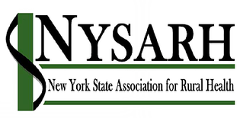
NYS Association for Rural Health
10 Kennedy Parkway
Cortland, NY 13045
607-756-4198
info@NYSARH.org
Jackie Leaf, Executive Director

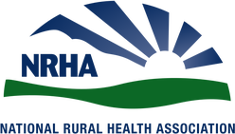
2019 Rural Health Advocacy
January 28, 2019
Albany, NY

2019 NYSARH Talking Points
Restore Full Funding for the Population Health Improvement Program
This program funds many activities that address the social determinants of health in rural communities
Restore Full Funding for Rural Health Networks RHNs address the social determinants of health by bringing together healthcare providers, nonprofit agencies, community advocates, local governments and business leaders to tackle local problems where they can be solved most effectively – locally!
Restore Full Funding for Rural Health Workforce Development
- Area Health Education Centers
- Provider recruitment & support
- STEM and pipeline programs
- Doctors Across NY
- Rural health access programs
- Graduate medical education
- Medical school rural residencies
- Worker retraining

Rethink current approaches to non-emergency medical transportation
- Preserve public transportation
- Support volunteer engagement
- Improve customer service

Explore new paradigms for rural EMS
- Support volunteer engagement
- Increase training flexibility
- Para-Medicine
- Support long-term care options

Restore funding for disease & accident prevention programs
These programs address the primary causes of mortality and morbidity in NY

Additional Priorities
- Tele-Health
- Maternal and Child Health
- Oral Health
- Healthcare Navigators
- Broadband

Thank You for raising the age to purchase tobacco products to 21 and for restricting vaping e-cigarettes
NYSARH Members are…

Rural Health Networks
Area Health Education Centers
Medical Providers
Federally Qualified Health Centers
Behavioral Health Agencies
County Public Health Departments
Hospitals & Urgent Care Centers
Schools of Higher Education
Health Foundations
Long Term Care Providers
Disease Prevention Organizations
Veteran Organizations
Community Action Agencies
Emergency Services

NYSARH Members …
Administer unique programs, tailored to rural communities
Deliver prevention and education services
Develop the health professionals of the future
Engage with DSRIP Performing Provider Systems
Implement the Population Health Improvement Program
Navigate healthcare and health insurance
Offer continuing education and internships
Partner with other organizations to leverage resources and maximize impact
Prepare for value-based payment
Provide or coordinate transportation
Reduce unnecessary hospital and emergency department visits
Solve community challenges at the community level

NYSARH …
Advocates for the health and well-being of Rural New Yorkers
Facilitates networking and collaboration across Upstate New York
Participates in the Rural Health Policy Institute in Washington, DC
Produces the premier Rural Health Conference in New York State
Publishes a Quarterly Newsletter
Represents New York with the National Rural Health Association

