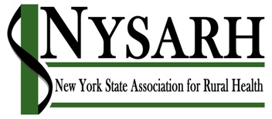
Board of Directors Meeting

January 22, 2019

11:00 AM – 12:00 PM
1-857-232-0476
Code: 610224

I Roll Call & Quorum Jackie

II Approval of Board Minutes 11.27.2018 Richard

III Committee Reports
- Policy Barry
  - Priorities
  - Albany Advocacy Day
  - Policy Institute
- Governance Claire
  - No Meetings in January or February
- Finance Rich K.
  - FY 2019 Budget (2 attachments)
  - FY 2018 Q4 Financial Reports will be sent Tuesday morning

- Membership Jack
- Conference Charlotte/David

IV Executive Director’s Report Jackie

VIII Other Business Richard

IX Next Meeting Jackie

X Adjourn Richard

