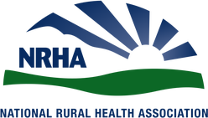
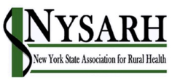
Legislative Meeting Tips

#1: Have an Ask • Be specific in your ask: Cosponsor S. 1234.
• Be able to articulate the problem, potential policy solution(s), and how you want them to help.
• You are building a relationship with this request, so take the time to discuss the data, your facility and how this bill will help your facility, community and state.

#2: Talk to the Right Person • Make a request in person, in addition to written requests.
• Understand the jurisdiction of the individual you are speaking with.
• Staffers can be your greatest asset.
Get to know them!

#3: Know Your Legislator • Do your homework! Know the issue, data/impacts, and how your member can engage.
• Know the member: Committee assignments, past legislative initiatives, rural health background.
• Do not assume they are experts in an issue.
Allow questions!

#4 Explain its Importance • How is this important to your state or region?
• What data and research can you use to support it.
• Personalize it! How does your experience support the data?

#5 Be Concise & Follow Up • Understand time constraints.
• Follow-up by email—send important information and handouts with follow-up email.
• Make yourself an information resource.

Credit: Carrie Cochran-McClain, NRHA

